# Update the EsOCL for web application

The EsOCL is developed as a standalone application so we package the source code and .class files of EsOCL as a .jar file. If we should update the EsOCL module of web application, we can just update the EsOCL.jar file in the /WebRoot/WEB-INF/lib.

# Configure the environment of JAVA

<http://vietpad.sourceforge.net/javaonwindows.html>

# Configure the environment of Tomcat

Once you have installed the Tomcat, you should configure the environment for the server.

①Click Start > Control Panel > System icon to open System Properties dialog box. Click Advanced > Environment Variables

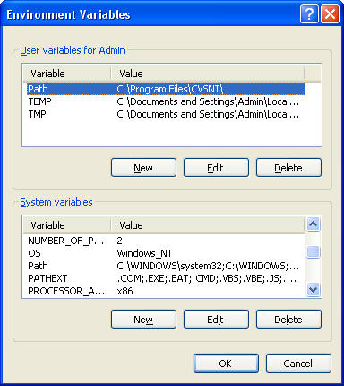

②Create CATALINA_HOME variables in system variables panel as: C:\ apache-tomcat-6.0.33;

③Add %CATALINA_HOME%\common\lib; at the end of CLASSPATH value

④Add %CATALINA_HOME%\bin; after the %JAVA_HOME%\bin; in the Path variable.

④Configure the server in the preference of myeclipse

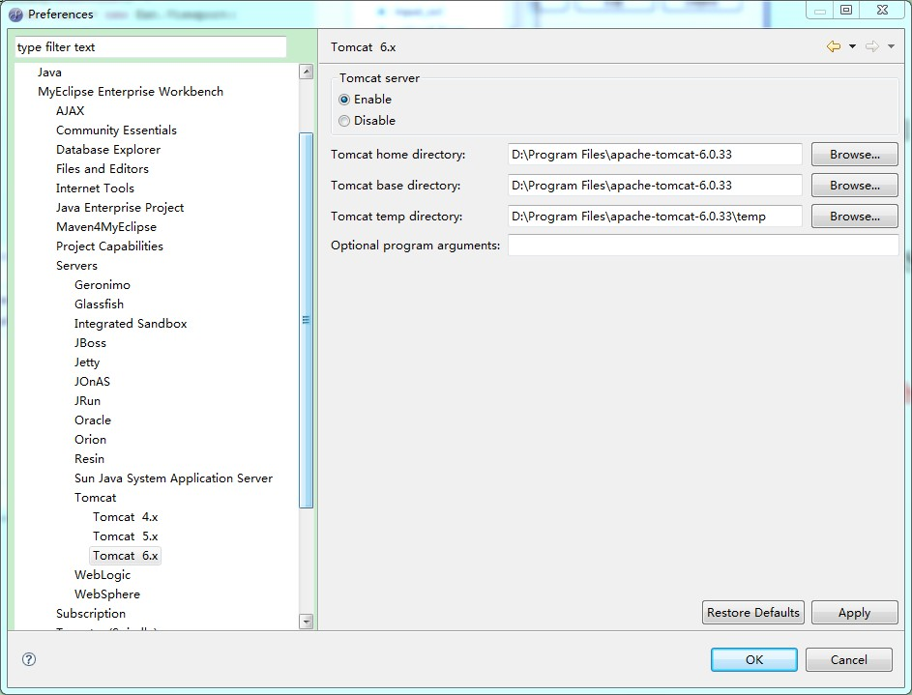

# Deploy the web application

①Import the web project into the workspace of myeclipse

②Click the “deploy” button, add the project and choose the server.

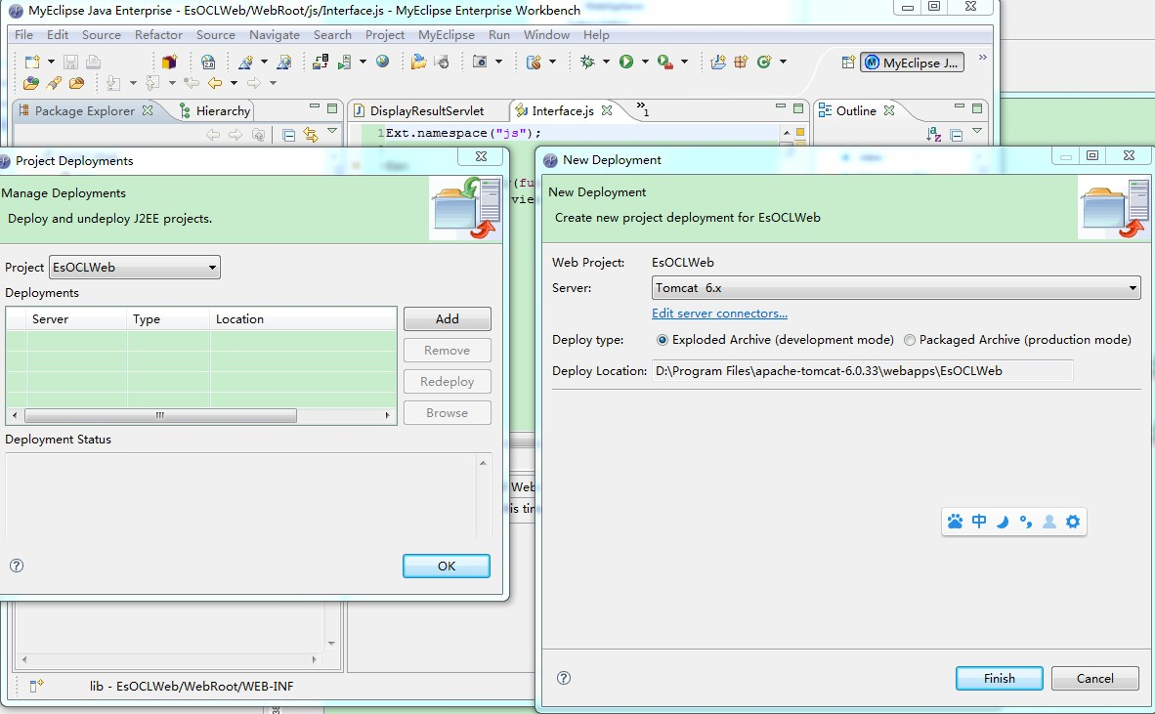

③After deploying the project, we can start the server and access the website. http://localhost:8080/EsOCLWeb/index.jsp